Python(22AIE205) Programming Lab

Weekly Lab Report-3

LAB 3: Control statements.

Name: | C.Pranaveswar
Roll No. | AIE25102
Section: | AIE-B
Department: | Artificial Intelligence and Engineering
Experiment Date: | 25-07-2026

Experiment Record:
Date: | 25-07-2026
Experiment Name: | Control statements
Aim: | To practice Control statements using Python IDLE.
Software Required: | Python 3.x and Python IDLE

Questions Given:
- 1. Write a Python program using a while loop to simulate a bus ticket booking counter with the following requirements:
- The bus has a total capacity of 40 seats.
- The program should keep asking the user how many tickets they want to book, until they choose to exit (by entering 0).
- For each booking request:
  - If the requested number of tickets is available, confirm the booking and reduce the available seat count.
  - If the requested number exceeds available seats, display an appropriate message showing how many seats are actually left.
  - If the bus becomes fully booked, display a "Bus Full" message and stop accepting further bookings automatically.
- At the end (whether by user exit or bus becoming full), display the total number of tickets sold and the total seats remaining.
2. Write a program using a while loop that allows a user a maximum of 3 attempts to enter the correct 4-digit ATM PIN. Display "Access Granted" on success. If all 3 attempts fail, display "Account Locked" and terminate.
3. Write a program using a while loop that generates a random number between 1 and 50 and allows the user to keep guessing until they guess correctly. After each guess, display whether the guess was too high or too low. Display the total number of attempts taken once the correct number is guessed.
4: Write a program using a while loop to manage a shop's inventory starting with 50 units in stock. The program should repeatedly accept the number of units sold, update the stock, and display a "Reorder Alert" when stock falls to 10 or below. The loop should terminate when the user enters -1 or stock reaches 0.

Programs, Sample Outputs and Results:
Question 1: Write a Python program using a while loop to simulate a bus ticket booking
Program:
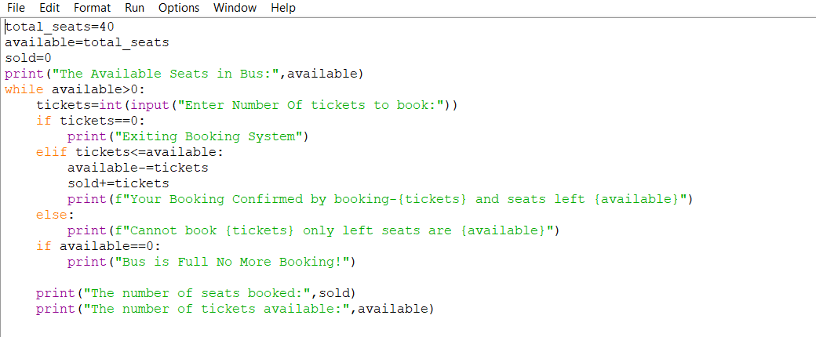
Input and Output:
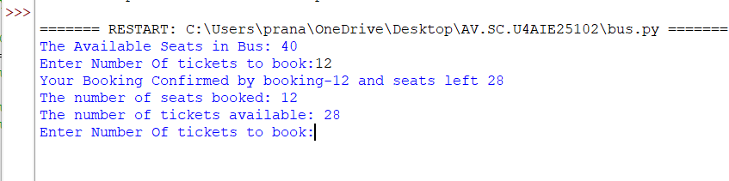
Result: The program executed successfully by taking input from user to book bus tickets and displayed number of tickets available after booking.
Question-2: Write a program using a while loop that allows a user a maximum of 3 attempts to enter the correct 4-digit ATM PIN. Display "Access Granted" on success. If all 3 attempts fail, display "Account Locked" and terminate.Program:
Python Code:
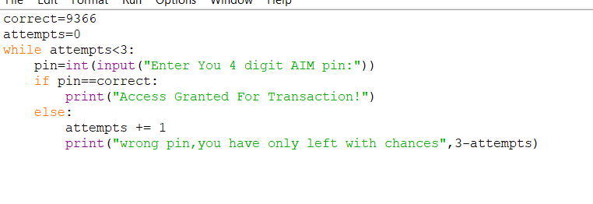
Input&Output:
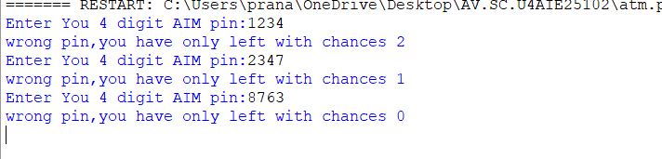
Result:The program is executed successfully ,by taking input from user and applied all conditions by given 3 chances for correct input identification
Question-3: Write a program using a while loop that generates a random number between 1 and 50 and allows the user to keep guessing until they guess correctly. After each guess, display whether the guess was too high or too low. Display the total number of attempts taken once the correct number is guessed.
Program:
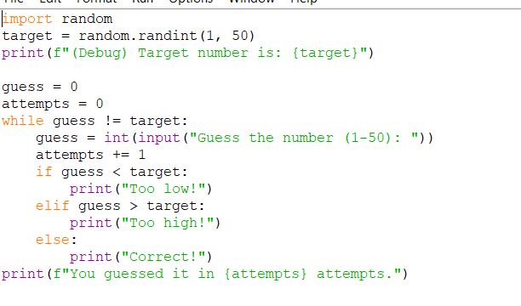Input & Output:
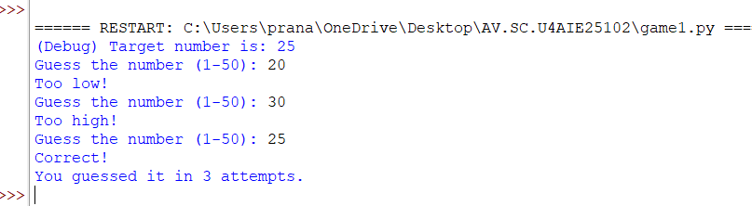
Question-4: Write a program using a while loop to manage a shop's inventory starting with 50 units in stock. The program should repeatedly accept the number of units sold, update the stock, and display a "Reorder Alert" when stock falls to 10 or below. The loop should terminate when the user enters -1 or stock reaches 0.
Program:
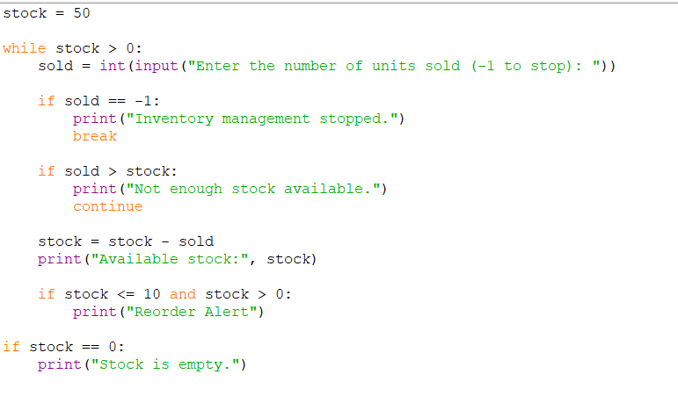
Input&Output:
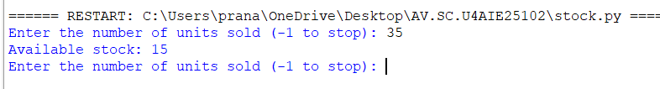
4. Observations
Imported “random” ,and used randint() function to generate a random integer.
And loop exits when condition fails or break.
5. Overall Result
All 4 programs Executed Successfully used while and if elif in necessary conditions.

